**IB Chemistry HL**

**Topic 6 Questions**

*Questions 1 and 2 refer to the following reaction.*

X2 + Y2 → XY

The reaction occurs in a series of steps.

X2 → 2X slow

X + Y → XY fast

**1.** What is the rate-determining step for this reaction mechanism?

A. X2 + 2 Y → 2 XY B. X2 + Y → XY + X

C. X2 → 2 X D. X + Y → XY

**2.** What is the rate expression for this reaction?

A. rate = k [XY] B. rate = k [X2][Y]2

C. rate = k [X2] D. rate = k [2X]

**3.** Consider the following reaction.

5 Br− (aq) + BrO3− (aq) + 6 H+ (aq) → 3 Br2 (aq) + 3 H2O (l)

The rate expression for the reaction is found to be:

rate = k [Br−] [BrO3−] [H+]2

Which statement is correct?

A. The overall order is 12.

B. Doubling the concentration of all of the reactants at the same time would increase the rate of the

reaction by a factor of 16.

C. The units of the rate constant, k, are mol dm –3 s –1.

D. A change in concentration of Br– or BrO3− does not affect the rate of the reaction.

**4.** The rate expression for a reaction is:

rate = k [X] [Y]

Which statement is correct?

A. As the temperature increases the rate constant decreases.

B. The rate constant increases with increased temperature but eventually reaches a constant value.

C. As the temperature increases the rate constant increases.

D. The rate constant is not affected by a change in temperature.

**5.** Consider the following reaction mechanism.

Step 1 H2O2 + I− → H2O + IO− slow

Step 2 H2O2 + IO− → H2O + O2 + I− fast

Which statement correctly identifies the rate-determining step and the explanation?

A. Step 2 because it is the faster step B. Step 1 because it is the slower step

C. Step 1 because it is the first step D. Step 2 because it is the last step

**6.** The activation energy of a reaction may be determined by studying the effect of a particular variable

on the reaction rate. Which variable must be changed?

A. pH B. Concentration C. Surface area D. Temperature

**7.** Two species, P and Q, react together according to the equation: P + Q → R

The accepted mechanism for this reaction is

P + P  P2 fast

P2 + Q → R + P slow

What is the order with respect to P and Q?

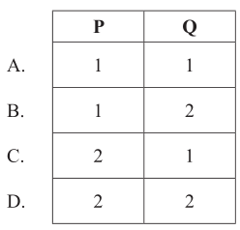

*Questions 8 and 9 refer to the following reaction.*

Sodium thiosulfate solution, Na2S2O3 (aq), and hydrochloric acid, HCl (aq), react spontaneously to produce solid sulfur, S (s), according to the equation below.

S2O32− (aq) + 2 H+ (aq) → S (s) + SO2 (aq) + H2O (l)

A student experimentally determined the rate expression to be:

rate = k [S2O32– (aq)]2

**8.** Which graph is consistent with this information?

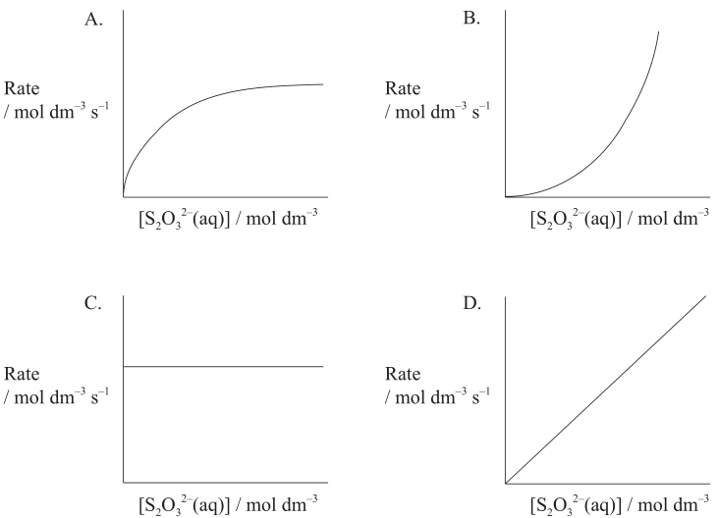

**9.** Which reaction could be the rate-determining step?

A. S2O32− (aq) + H+ (aq) → S2O2 (aq) OH− (aq) B. S2O32− (aq) + 2 H+ (aq) → S2O2 (aq) + H2O (l)

C. S2O32− (aq) → S (s) (aq) + SO32− D. 2 S2O32− (aq) → S4O64− (aq)

**10.** The following data were obtained for the reaction between gases A and B.

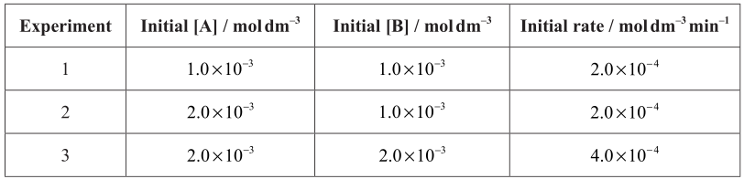

Which relationship represents the rate expression for the reaction?

A. rate = k [B]2 B. rate = k [A]2 C. rate = k [A] D. rate = k [B]

**11.** Consider the following reaction.

NO2 (g) + CO(g) → NO (g) + CO (g)

At T <227 °C the rate expression is rate = k [NO2]2. Which of the following mechanisms is

consistent with this rate expression?

A. NO2 + NO2  N2O4 fast

N2O4 + 2 CO → 2 NO + CO2 slow

B. NO2 + CO → NO + CO2 slow

C. NO2 → NO + O slow

CO + O → CO2 fast

D. NO2 + NO2 → NO3 + NO slow

NO3 + CO → NO2 + CO2 fast

**12.** Consider the reaction: 2 P + Q → R + S

This reaction occurs according to the following mechanism.

P + Q → X slow

P + X → R + S fast

What is the rate expression?

A. rate = k [P] B. rate = k [P] [X] C. rate = k [P] [Q] D. rate = k [P]2 [Q]

**13.** What happens when the temperature of a reaction increases?

A. The activation energy increases.

B. The rate constant increases.

C. The enthalpy change increases.

D. The order of the reaction increases.

**14.** Which of the following can increase the rate of a chemical reaction?

I. Increasing the temperature

II. Adding a catalyst

III. Increasing the concentration of reactants

A. I and II only B. I and III only C. II and III only D. I, II and III

**15.** Bromine and nitrogen(II) oxide react according to the following equation.

Br2 (g) + 2 NO (g) → 2 NOBr (g)

Which rate equation is consistent with the experimental data?

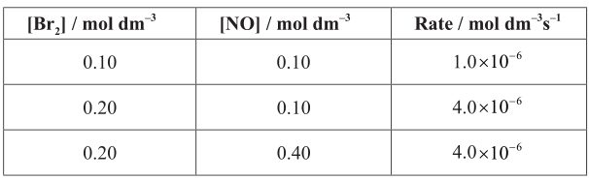

A. rate = k [Br2]2 [NO] B. rate = k [Br2] [NO]2

C. rate = k [Br2]2 D. rate = k [NO]2

**16.** Consider the reaction between gaseous iodine and gaseous hydrogen.

I2 (g) + H2 (g)  2 HI (g) ΔHᶱ = −9 kJ

Why do some collisions between iodine and hydrogen not result in the formation of the product?

A. The I2 and H2 molecules do not have sufficient energy.

B. The system is in equilibrium.

C. The temperature of the system is too high.

D. The activation energy for this reaction is very low.

**17.** Which step is the rate-determining step of a reaction?

A. The step with the lowest activation energy B. The final step

C. The step with the highest activation energy D. The first step

**18.** The rate information below was obtained for the following reaction at a constant temperature.

2 NO2 (g) + F2 (g) → 2 NO2F (g)

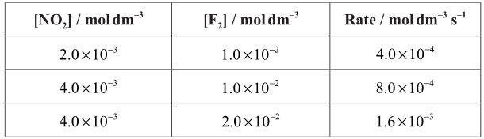

What are the orders of the reaction with respect to NO2 and F2?

A. NO2 is first order and F2 is second order

B. NO2 is second order and F2 is first order

C. NO2 is first order and F2 is first order

D. NO2 is second order and F2 is second order

**19.** Consider the following reaction.

2 NO (g) + 2 H2 (g) → N2 (g) + 2 H2O (g)

A proposed reaction mechanism is:

NO (g) + NO (g)  N2O2 (g) fast

N2O2 (g) + H2 (g) → N2O (g) + H2O (g) slow

N2O (g) + H2 (g) → N2 (g) + H2O (g) fast

What is the rate expression?

A. rate = k [H2] [NO]2 B. rate = k [N2O2] [H2]

C. rate = k [NO]2 [H2]2 D. rate = k[NO]2 [N2O2]2 [H2]

**20.** The rate expression for the reaction between iodine and propanone with an acid catalyst is found

to be: rate = k [H+]1 [I2]0 [CH3COCH3]1

What is the overall order of the reaction?

A. 0 B. 1 C. 2 D. 3

**21.** Which graph represents a reaction that is first order with respect to reactant A.

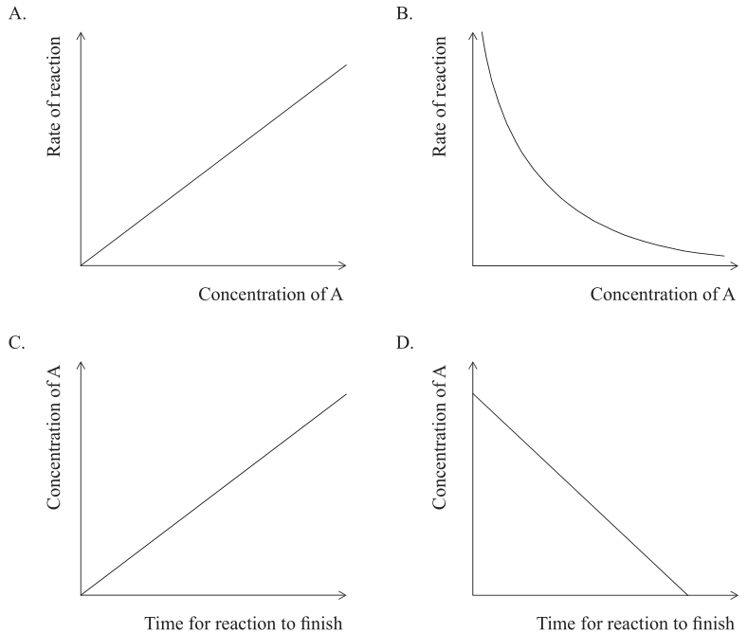

**22.** The decomposition of N2O5 occurs according to the following equation.

2 N2O5 (g) → 4 NO2 (g) + O2 (g)

The reaction is first order with respect to N2O5. What combination of variables could the axes represent on the graph below?

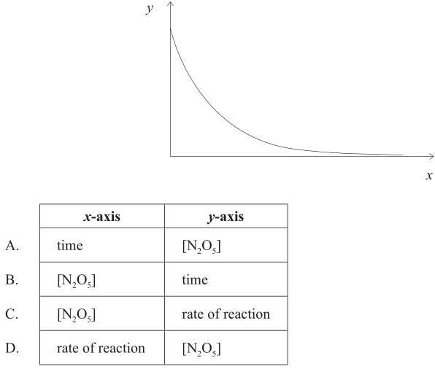

**23.** What is the effect of an increase in temperature on the rate constant of the forward reaction, k, and on

the equilibrium constant, Kc, of an exothermic reversible reaction?

A. k decreases, Kc increases B. k increases, Kc decreases

C. k decreases, Kc decreases D. k increases, Kc increases

**24.** The graph represents the rates of the forward and backward reactions of a reversible reaction.

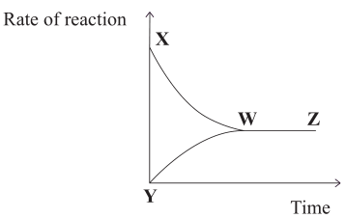

Which statement is correct?

A. XWZ represents the rate of the forward reaction.

B. At Y, the rate of the forward and backward reactions is zero.

C. Between W and Z, the concentrations of products and reactants are equal.

D. Between Y and W, the concentration of the reactants increases.

**25.** Which graph represents a reaction that is second order with respect to X for the reaction: X → products?

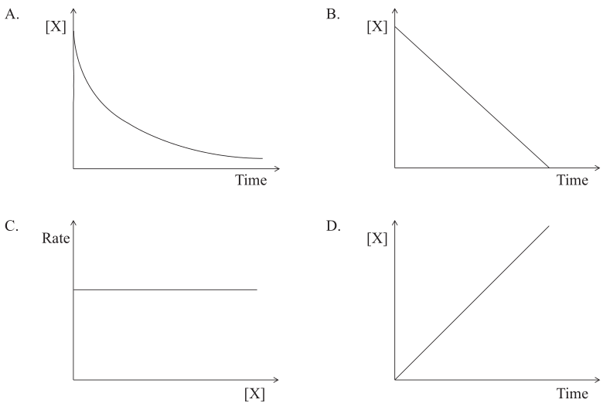

**26.** Which graph best represents a second-order reaction?

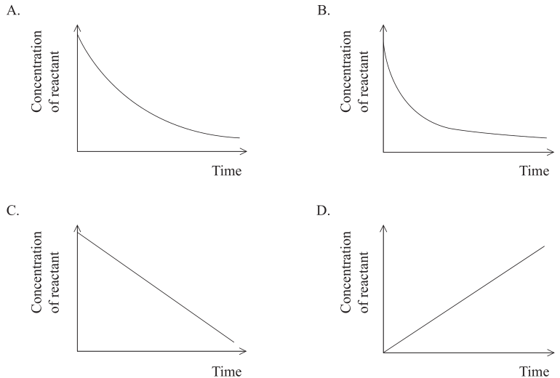

**27.** For the gas phase reaction: A (g) + B (g) → C (g)

the experimentally determined rate expression is: rate = k [A] [B]2

By what factor will the rate change if the concentration of A is tripled and the concentration of B is halved?

A. 0.75 B. 1.5 C. 6 D. 12

**28.** Which statement about a reaction best describes the relationship between the temperature, T,

and the rate constant, k?

A. As T increases, k decreases linearly. B. As T increases, k decreases non-linearly.

C. As T increases, k increases linearly. D. As T increases, k increases non-linearly.

**29.** The following experimental rate data were obtained for a reaction carried out at temperature T.

A (g) + B (g) → C (g) + D(g)

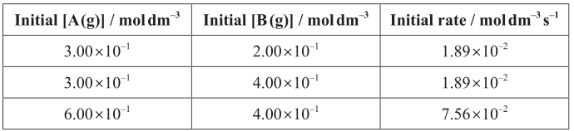

What are the orders with respect to A (g) and B (g)?

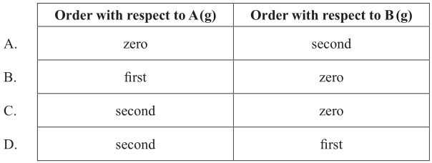

**30.** Consider the following proposed two-step reaction mechanism at temperature T.

k1

Step 1: 2 NO2 (g) → NO (g) + NO3 (g) slow

k2

Step 2: NO3 (g) + CO (g) → NO2 (g) + CO2 (g) fast

Which statements are correct?

I. The overall reaction is NO2 (g) + CO (g) → NO (g) + CO2 (g).

II. Step 1 is the rate-determining step of the reaction.

III. The rate expression for Step 1 is rate = k1 [NO2]2.

A. I and II only B. I and III only C. II and III only D. I, II and III

**31.** **(a)** Nitrogen monoxide reacts at 1280 °C with hydrogen to form nitrogen and water.

All reactants and products are in the gaseous phase.

**(i)** The kinetics of the reaction were studied at this temperature. The table shows the initial rate of reaction for different concentrations of each reactant.

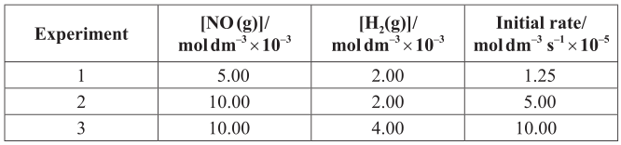

Deduce the order of the reaction with respect to NO and H2, and explain your reasoning. *[4]*

*_________________________________________________________________________________________**_________________________________________________________________________________________**_________________________________________________________________________________________**_________________________________________________________________________________________**_________________________________________________________________________________________* **(ii)** Deduce the rate expression for the reaction. *[1]*

*__________________________________________________________________________________________________________________________________________________________________________________*

**(iii)** Determine the value of the rate constant for the reaction from Experiment 3 and state its units. *[2]*

*____________________________________________________________________________________________________________________________________________________________________________________________________________________________________________________________________________________________________________________________________________________________________*

**(b)**  The gas-phase decomposition of dinitrogen monoxide is considered to occur in two steps.

k1

Step 1: N2O (g) → N2 (g) + O (g)

k2

Step 2: N2O (g) + O (g) → N2 (g) + O2 (g)

The experimental rate expression for this reaction is rate = k [N2O].

**(i)** Identify the rate-determining step. *[1]*

*_________________________________________________________________________________________*

*_________________________________________________________________________________________*

**(ii)** Identify the intermediate involved in the reaction. *[1]*

*__________________________________________________________________________________________________________________________________________________________________________________*

**(c)** The conversion of CH3NC into CH3CN is an exothermic reaction which can be represented as follows.

CH3–N≡C → transition state → CH3–C≡N

This reaction was carried out at different temperatures and a value of the rate constant, k, was obtained for each temperature. A graph of ln k against 1/T is shown below.

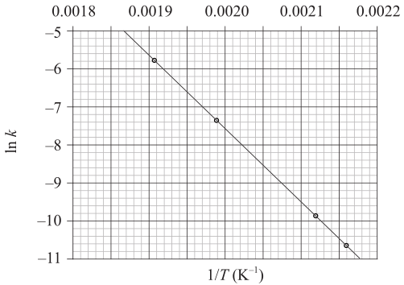

**(i)** Define the term activation energy, Ea. *[1]*

*_________________________________________________________________________________________*

*___________________________________________________________________________________________________________________________________________________________________________________________________________________________________________________________________________*

**(ii)** Construct the enthalpy level diagram and label the activation energy, Ea, the enthalpy change, ∆H, and the position of the transition state. *[3]*

*_________________________________________________________________________________________*

**(iii)**  Describe qualitatively the relationship between the rate constant, k, and the temperature, T. *[1]*

*___________________________________________________________________________________________________________________________________________________________________________________________________________________________________________________________________________*

**(iv)** Calculate the activation energy, Ea, for the reaction, using Table 1 of the Data Booklet. *[4]*

*__________________________________________________________________________________________________________________________________________________________________________________*

*_________________________________________________________________________________________*

*_________________________________________________________________________________________*

*_________________________________________________________________________________________*

**32. (a)** Consider the following reaction studied at 263 K.

2 NO (g) + Cl2 (g)  2 NOCl (g)

It was found that the forward reaction is first order with respect to Cl2 and second order with respect to NO. The reverse reaction is second order with respect to NOCl.

**(i)** State the rate expression for the forward reaction. *[1]*

*_________________________________________________________________________________________*

**(ii)** Predict the effect on the rate of the forward reaction and on the rate constant if the concentration of NO is halved. *[2]*

*_________________________________________________________________________________________*

*_________________________________________________________________________________________**_________________________________________________________________________________________*

**(iii)** 1.0 mol of Cl2 and 1.0 mol of NO are mixed in a closed container at constant temperature. Sketch a graph to show how the concentration of NO and NOCl change with time until after equilibrium has been reached. Identify the point on the graph where equilibrium is established. *[4]*

*_________________________________________________________________________________________*

*_________________________________________________________________________________________**_________________________________________________________________________________________*

*_________________________________________________________________________________________*

*_________________________________________________________________________________________**_________________________________________________________________________________________*

**(b)** Consider the following reaction.

NO2 (g) + CO (g) → NO (g) + CO2 (g)

Possible reaction mechanisms are:

Above 775 K: NO2 + CO → NO + CO2 slow

Below 775 K: 2 NO2 → NO + NO3 slow

NO3 + CO → NO2 + CO2 fast

Based on the mechanisms, deduce the rate expressions above and below 775 K. *[2]*

*_________________________________________________________________________________________**_________________________________________________________________________________________*

**(c)** State two situations when the rate of a chemical reaction is equal to the rate constant. *[2]*

*_________________________________________________________________________________________**_________________________________________________________________________________________*

*_________________________________________________________________________________________**_________________________________________________________________________________________*

**(d)** Consider the following graph of ln k against 1/T for the first order decomposition of N2O4 into NO2. Calculate the activation energy in kJ mol–1 for this reaction. *[2]*

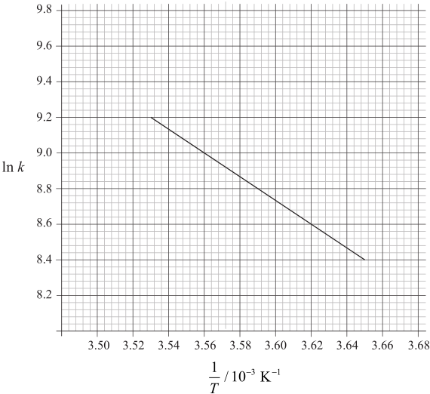

*_________________________________________________________________________________________**_________________________________________________________________________________________*

*_________________________________________________________________________________________**_________________________________________________________________________________________*

*_________________________________________________________________________________________*

*_________________________________________________________________________________________*

**33.** Alex and Hannah were asked to investigate the kinetics involved in the iodination of propanone.

They were given the following equation by their teacher.

H+ (aq)

CH3COCH3 (aq) + I2 (aq) ---→ CH2ICOCH3 (aq) + HI (aq)

Alex’s hypothesis was that the rate will be affected by changing the concentrations of the propanone and the iodine, as the reaction can happen without a catalyst.

Hannah’s hypothesis was that as the catalyst is involved in the reaction, the concentrations of the propanone, iodine and the hydrogen ions will all affect the rate.

They carried out several experiments varying the concentration of one of the reactants or the catalyst whilst keeping other concentrations and conditions the same, and obtained the results below.

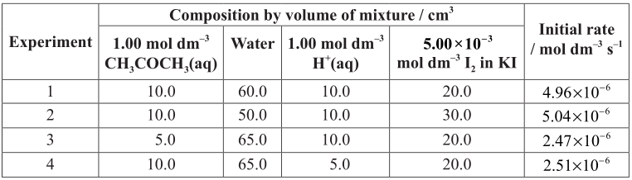

**(a)** Explain why they added water to the mixtures. *[1]*

*_________________________________________________________________________________________*

*_________________________________________________________________________________________*

**(b) (i)** Deduce the order of reaction for each substance and the rate expression from the results. *[2]*

*_________________________________________________________________________________________*

*_________________________________________________________________________________________*

*_________________________________________________________________________________________*

*_________________________________________________________________________________________*

**(ii)** Comment on whether Alex’s or Hannah’s hypothesis is correct. *[1]*

*_________________________________________________________________________________________*

*_________________________________________________________________________________________*

**(c)** Using the data from Experiment 1, determine the concentration of the substances used and the rate constant for the reaction including its units. *[3]*

*_________________________________________________________________________________________*

*_________________________________________________________________________________________*

*_________________________________________________________________________________________*

*_________________________________________________________________________________________*

*_________________________________________________________________________________________*

**(d) (i)** This reaction uses a catalyst. Sketch and annotate the Maxwell-Boltzmann energy distribution curve for a reaction with and without a catalyst on labelled axes below. *[3]*

*_________________________________________________________________________________________*

**(ii)** Describe how a catalyst works. *[1]*

*_________________________________________________________________________________________*

*_________________________________________________________________________________________*

**34.** Consider the following graph of ln k against 1/T (temperature in Kelvin) for the second order decomposition of N2O into N2 and O: N2O → N2 + O

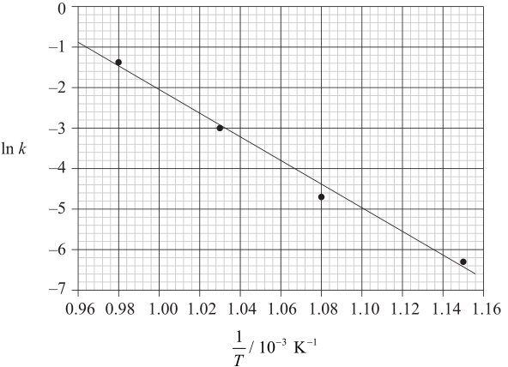

**(a)** State how the rate constant, k varies with temperature, T. *[1]*

*_________________________________________________________________________________________*

*_________________________________________________________________________________________*

**(b)** Determine the activation energy, Ea, for this reaction. *[3]*

*_________________________________________________________________________________________*

*_________________________________________________________________________________________*

*_________________________________________________________________________________________*

*_________________________________________________________________________________________*

*_________________________________________________________________________________________*

*_________________________________________________________________________________________*

**(c)** The rate expression for this reaction is rate = k [N2O]2 and the rate constant is 0.244 dm3 mol–1 s–1 at 750 °C.

A sample of N2O of concentration 0.200 mol dm–3 is allowed to decompose. Calculate the rate when 10 % of the N2O has reacted. *[2]*

*_________________________________________________________________________________________*

*_________________________________________________________________________________________*

*_________________________________________________________________________________________*

*_________________________________________________________________________________________*

**35. (a)** Define the term activation energy, Ea. *[1]*

*_________________________________________________________________________________________*

*_________________________________________________________________________________________*

**(b)** Nitrogen monoxide, NO, is involved in the decomposition of ozone according to the following mechanism.

O3 → O2 + O·

O3 + NO → NO2 + O2

NO2 + O· → NO + O2

Overall: 2 O3 → 3 O2

State and explain whether or not NO is acting as a catalyst. *[2]*

*_________________________________________________________________________________________*

*_________________________________________________________________________________________*

*_________________________________________________________________________________________*

*_________________________________________________________________________________________*

**(c) (i)** Define the term endothermic reaction. *[1]*

*_________________________________________________________________________________________*

*_________________________________________________________________________________________*

**(ii)** Sketch the Maxwell-Boltzmann energy distribution curve for a reaction with and without a catalyst, and label both axes. *[3]*

*_________________________________________________________________________________________*

**(d)** BF3 (g) reacts with NH3 (g) to form F3BNH3 (g) according to the equation below.

BF3 (g) + NH3 (g) → F3BNH3 (g)

The table below shows initial rates of reaction for different concentrations of each reactant for this reaction at temperature, T.

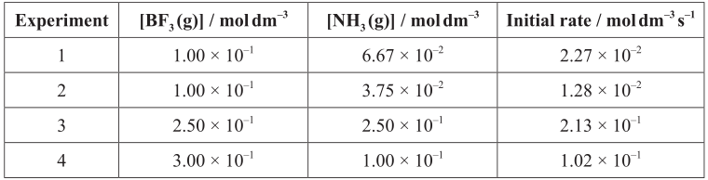

Deduce the rate expression, the overall order of the reaction and determine the value of k, the rate constant, with its units, using the data from Experiment 4. *[3]*

*_________________________________________________________________________________________*

*_________________________________________________________________________________________*

*_________________________________________________________________________________________*

*_________________________________________________________________________________________*

*_________________________________________________________________________________________*

*_________________________________________________________________________________________*

**(e)** The following is a proposed mechanism for the reaction of NO (g) with H 2 (g).

Step 1: 2 NO (g) → N2O2 (g)

Step 2: N2O2 (g) + H2 (g) → N2O(g) + H2O(g)

**(i)** Identify the intermediate in the reaction. *[1]*

*_________________________________________________________________________________________*

*_________________________________________________________________________________________*

**(ii)** The observed rate expression is rate = k [NO]2 [H2]. Assuming that the proposed mechanism is correct, comment on the relative speeds of the two steps. *[1]*

*_________________________________________________________________________________________*

*_________________________________________________________________________________________*

**(f)**  The following two-step mechanism has been suggested for the reaction of NO2 (g) with CO (g), where k2 >>k1.

k1

Step 1: NO2 (g) + NO2 (g) → NO (g) NO3 (g)

k2

Step 2: NO3 (g) + CO (g) → NO2 (g) + CO2 (g)

Overall: NO2 (g) + CO (g) → NO (g) + CO2 (g)

The experimental rate expression is rate = k [NO2]2. Explain why this mechanism produces a rate expression consistent with the experimentally observed one. *[2]*

*_________________________________________________________________________________________*

*_________________________________________________________________________________________*

*_________________________________________________________________________________________*

*_________________________________________________________________________________________*

**(g)** HI (g) decomposes into H2 (g) and I2 (g) according to the reaction below.

2 HI (g) → H2 (g) + I2 (g)

The reaction was carried out at different temperatures and a value of the rate constant, k, was obtained for each temperature. A graph of ln k against 1/T is shown below.

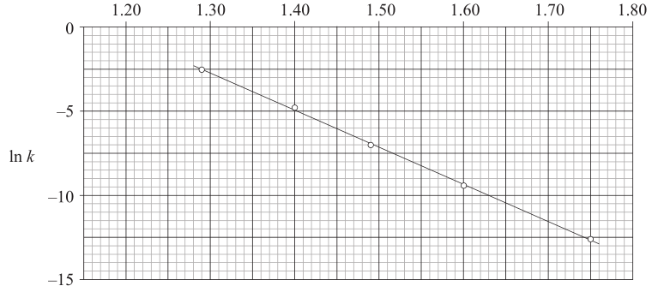

Calculate the activation energy, Ea, for the reaction using these data and Table 1 of the Data Booklet showing your working. *[4]*

*_________________________________________________________________________________________*

*_________________________________________________________________________________________*

*_________________________________________________________________________________________*

*_________________________________________________________________________________________*

*_________________________________________________________________________________________*

*_________________________________________________________________________________________*

*_________________________________________________________________________________________*

*_________________________________________________________________________________________*

**36.** The reaction between carbon monoxide, CO (g), and nitrogen dioxide, NO2 (g), was studied at different temperatures and a graph was plotted of ln k against 1/T.

The equation of the line of best fit was found to be:

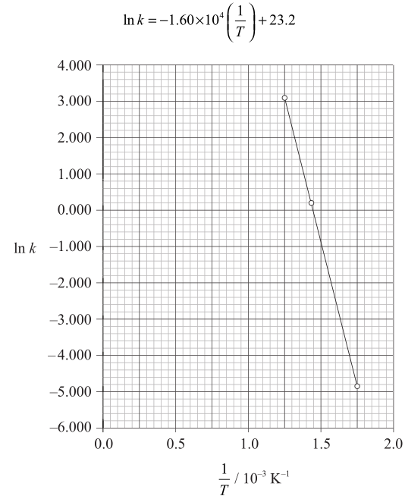

**(a)** The Arrhenius equation is shown in Table 1 of the Data Booklet. Identify the symbols k and A. *[2]*

k: *_______________________________________________________________________________________*

A: *______________________________________________________________________________________*

**(b)** Calculate the activation energy, Ea, for the reaction between CO (g) and NO2 (g). *[2]*

*_________________________________________________________________________________________*

*_________________________________________________________________________________________*

*_________________________________________________________________________________________*

*_________________________________________________________________________________________*

**(c)** Calculate the numerical value of A. *[2]*

*_________________________________________________________________________________________*

*_________________________________________________________________________________________*

*_________________________________________________________________________________________*

*_________________________________________________________________________________________*

**37.** Chemical kinetics involves an understanding of how the molecular world changes with time.

**(a)** Sketch graphical representations of the following reactions, for X → products.

**(i)** Concentration of reactant X against time for a **zero-order** reaction. *[1]*

*_________________________________________________________________________________________*

**(ii)** Rate of reaction against concentration of reactant X for a **zero-order** reaction. *[1]*

*_________________________________________________________________________________________*

**(iii)**  Rate of reaction against concentration of reactant X for a **first-order** reaction. *[1]*

*_________________________________________________________________________________________*

**(b)** For the reaction below, consider the following experimental data.

2 ClO2 (aq) + 2 OH– (aq) → ClO3– (aq) ClO2– (aq) + H2O (l)

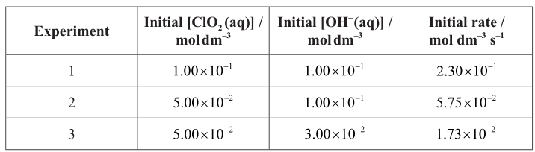

**(i)** Deduce the rate expression. *[2]*

*_________________________________________________________________________________________*

*_________________________________________________________________________________________*

*_________________________________________________________________________________________*

*_________________________________________________________________________________________*

**(ii)** Determine the rate constant, k, and state its units, using the data from Experiment 2. *[2]*

*_________________________________________________________________________________________*

*_________________________________________________________________________________________*

*_________________________________________________________________________________________*

*_________________________________________________________________________________________*

**(iii)** Calculate the rate, in mol dm–3 s–1, when [ClO2 (aq)] = 1.50 × 10–2 mol dm–3 and [OH– (aq)] = 2.35 × 10–2 mol dm–3. *[1]*

*_________________________________________________________________________________________*

*_________________________________________________________________________________________*

**(c)** Another reaction involving OH– (aq) is the base hydrolysis reaction of an ester.

CH3COOCH2CH3 (aq) + OH– (aq) → CH3COO– (aq) CH3CH2OH (aq)

**(i)** Apply IUPAC rules to name the ester, CH3COOCH2CH3 (aq). *[1]*

*_________________________________________________________________________________________*

*_________________________________________________________________________________________*

**(ii)** Describe **qualitatively** the relationship between the rate constant, k, and temperature, T. ***[1]***

*_________________________________________________________________________________________*

*_________________________________________________________________________________________*

**(iii)** The rate of this reaction was measured at different temperatures and the following data were recorded.

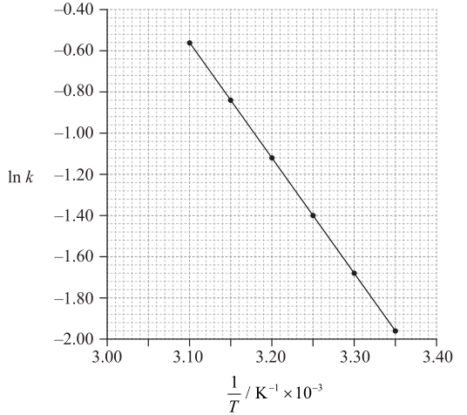

Using data from the graph, determine the activation energy, Ea, correct to **three** significant figures and **state its units**. *[4]*

*_________________________________________________________________________________________*

*_________________________________________________________________________________________*

*_________________________________________________________________________________________*

*_________________________________________________________________________________________*

*_________________________________________________________________________________________*

*_________________________________________________________________________________________*

*_________________________________________________________________________________________*

*_________________________________________________________________________________________*

**(d)** A two-step mechanism has been proposed for the following reaction.

Step 1: ClO– (aq) + ClO– (aq) → ClO2– (aq) + Cl– (aq)

Step 2: ClO2– (aq) ClO– (aq) → ClO3– (aq) Cl– (aq)

**(i)** Deduce the overall equation for the reaction. *[1]*

*_________________________________________________________________________________________*

*_________________________________________________________________________________________*

**(ii)** Deduce the rate expression for each step. *[2]*

Step 1: *__________________________________________________________________________________*

*_________________________________________________________________________________________*

Step 2: *__________________________________________________________________________________*

*_________________________________________________________________________________________*

**Answers**

1-5 C C B C B

6-10 D C B D D

11-15 D C B D C

16-20 A C C A C

21-25 A A B A A

26-30 B A D C D

31. (a)

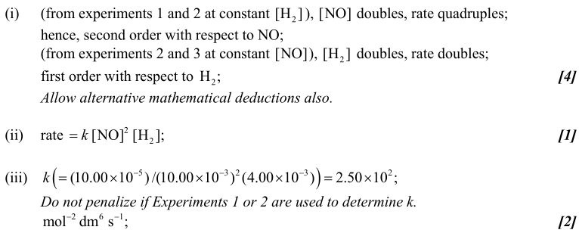

(b)

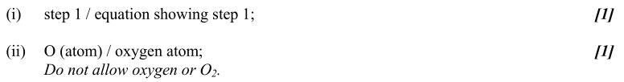

(c)

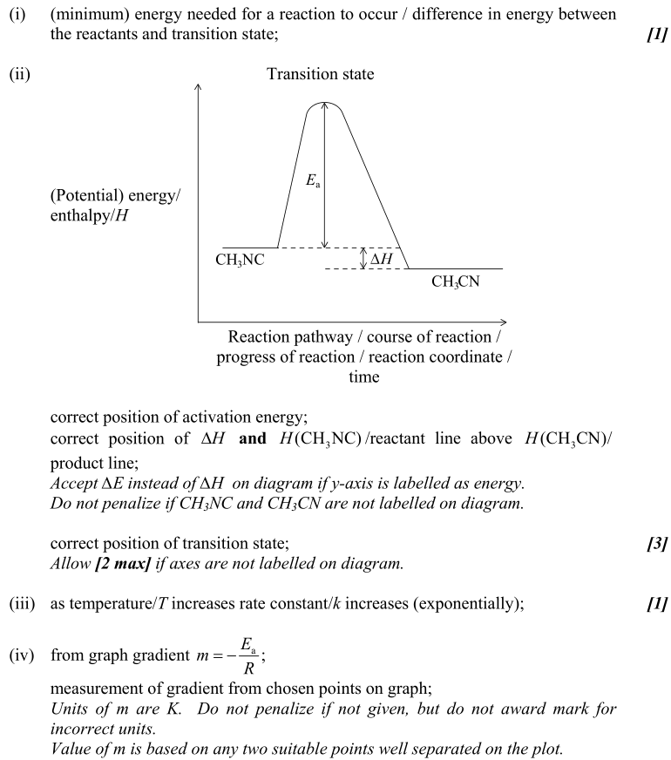

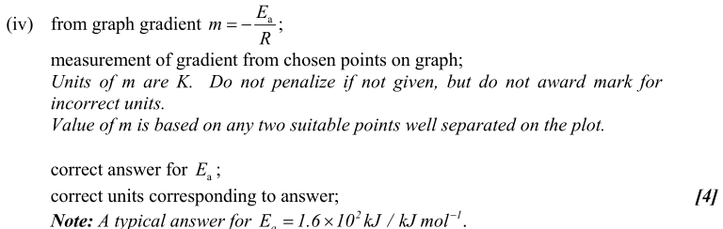

**32.**

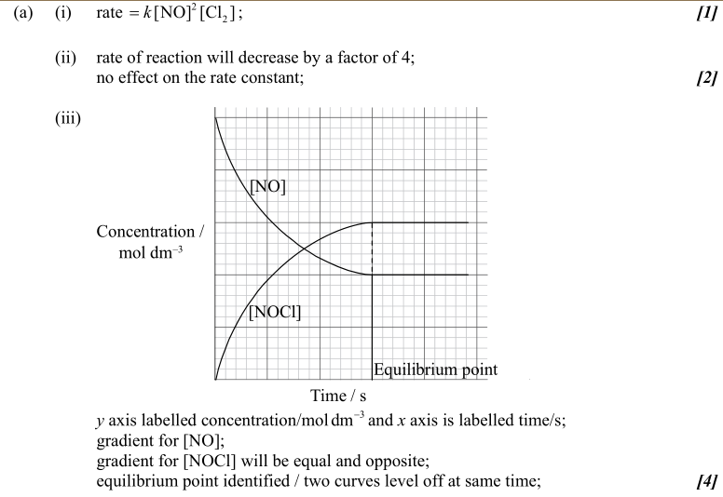

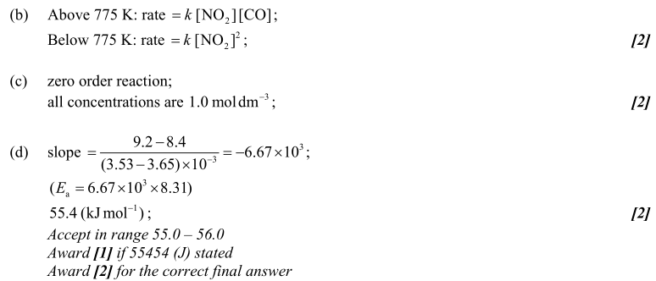

**33.**

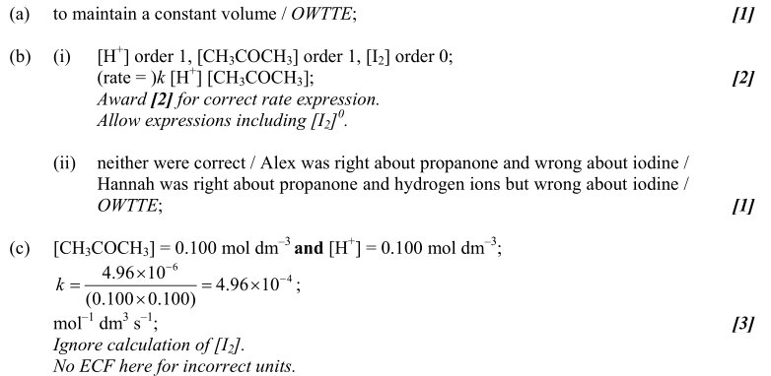

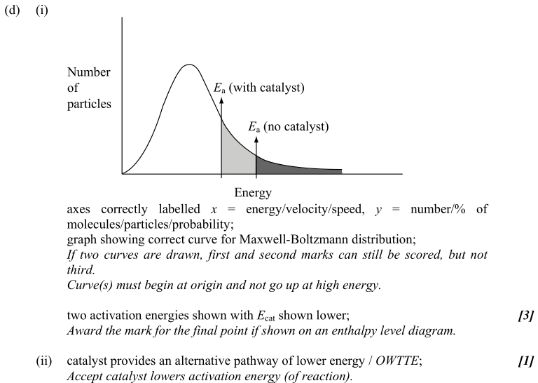

**34.**

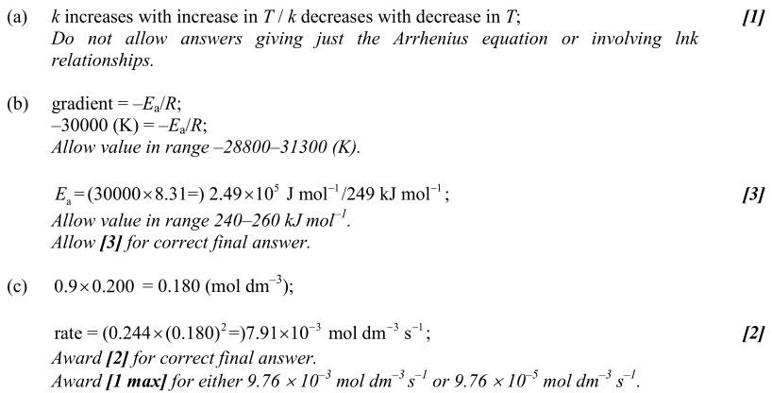

**35.**

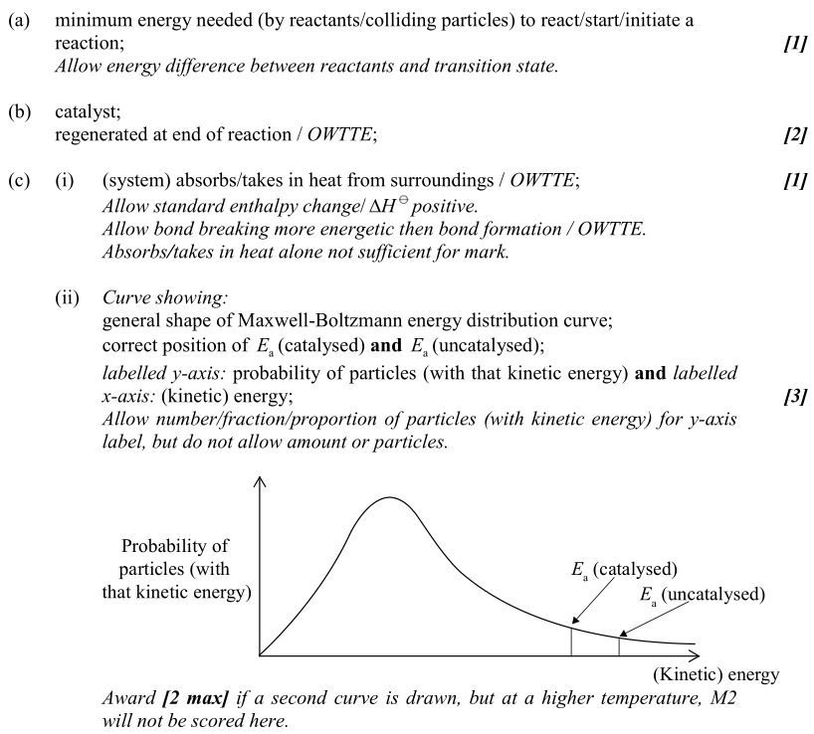

**(d)**

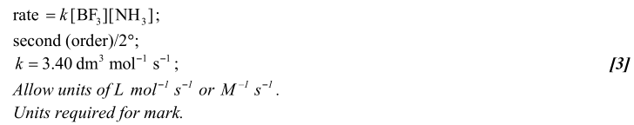

**(e)**

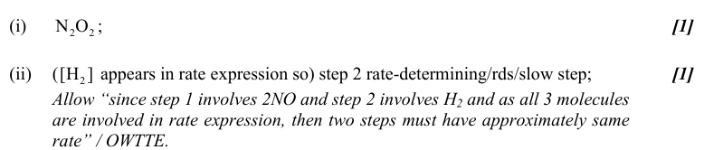

**(f)**

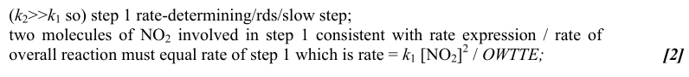

**(g)**

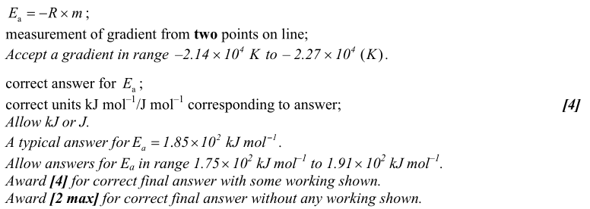

**36. (a)**

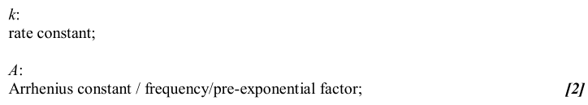

**(b)**

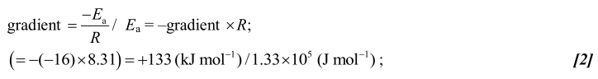

**(c)**



**37. (a)**

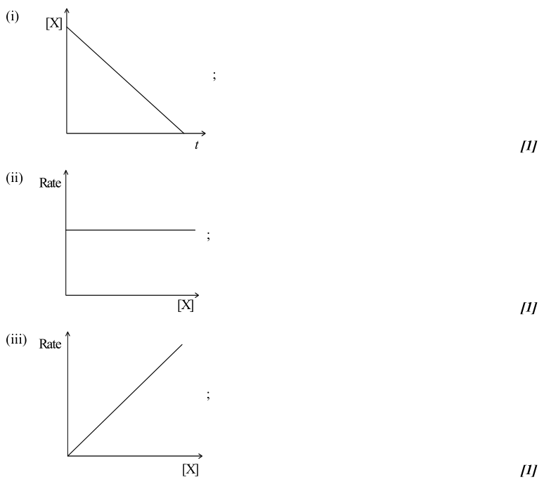**00**

**(b)**

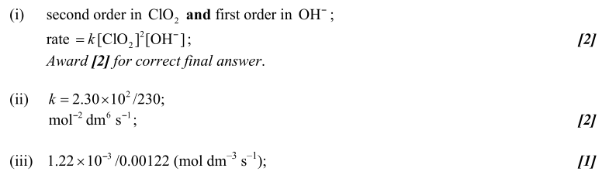

**(c)**

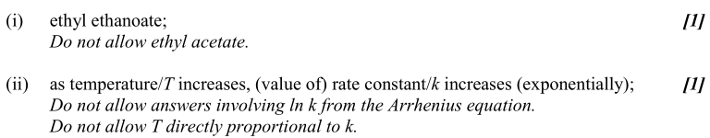

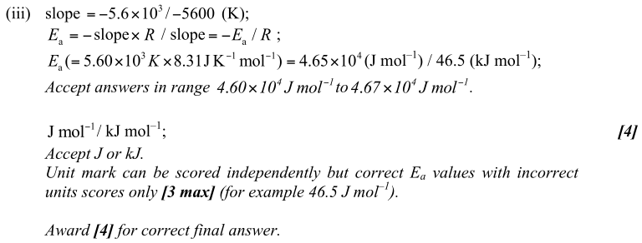

**(d)**

